PRT661 – Data Science Practice | Australian Electricity Demand Forecasting | WP4
Ashish Shrestha — WP4 Individual Contribution & Progress Report
Dan6 Theme 2 (Group 2) | Final modelling analysis, deep-learning evaluation and production model selection
Table 1. Student and WP4 role
Student | ID | WP4 role | Workstream / pair
Ashish Shrestha | S388084 | MLP implementation and overall model-selection integration | MLP pair with Bishal Dahal (independent validation); integration lead for the four WP4 modules

Evidence note
Numerical statements in this report come from the full academic run of Energy_Demand_Forecasting_Pipeline.py v4.0.0 (EnergyForecast_Run_20260929_145931, 426.7 minutes, status COMPLETE). Methodology statements refer to the same pipeline version.
The WP4 module attributed to Ashish is a current role-aligned collaboration artefact prepared from the team's integrated implementation for genuine branch-based review and merging. It does not claim or back-date earlier authorship. At the date of this report the module has been prepared and verified against the pipeline; the GitHub issue, branch, pull request and review described below are the next collaboration step and have not yet been created. Earlier-stage contributions follow the role boundaries recorded in the WP3 documents and the Meeting 6 minutes.

1. Allocated WP4 responsibility
Ashish's WP4 responsibility has two parts. The first is the Multilayer Perceptron (MLP) added after the lecturer/project feedback: its configuration, architecture, loss, input contract, training-only scaling, chronological validation, fit/predict wrapper and connection to the recursive four-month engine. The second continues his WP3 role as forecasting lead — Random Forest A/B, backtesting and regional selection — by integrating the evidence from all ten models into one final model-retention decision and leading the merge of the four WP4 modules.
The role therefore sits between the modelling code supplied by all four members and the final decision. Ashish builds the MLP; Bishal validates it independently. Ashish does not validate his own model.

2. Why an MLP was included
The MLP asks whether a neural network can extract more non-linear structure from the same engineered representation that the tree models use. It is the most direct neural counterpart to Random Forest: same recursion, same horizon, same origin-safe features, different learner. If it improved on Random Forest, the improvement could be attributed to the learning method rather than to extra information.
Table 2. MLP configuration implemented in the integrated pipeline
Component | Setting in pipeline v4.0.0
Inputs | Feature Set B without time_index, days_since_start, year (51 features, "B_nn"); median-filled, z-scored on training rows only
Architecture | Dense 128 → ReLU → Dropout 0.2 → Dense 64 → ReLU → Dropout 0.1 → Dense 1; 14,977 parameters
Loss / optimiser | Huber (δ = 0.5 target-SD units); Adam 1e-3; L2 1e-5; batch 512
Validation | Last 56 days before each origin; EarlyStopping (patience 8), ReduceLROnPlateau, maximum 100 epochs
Refit | All pre-origin rows for the early-stopped epoch count, replaying the learning-rate path
Forecasting | Same 48-interval day-block recursion and feature rebuild as Random Forest / XGBoost

Two design decisions are worth recording. Trend columns were withheld because a network extrapolates them linearly beyond the training range; trees plateau. The refit on all pre-origin rows was added so that the MLP sees the same eight weeks before the origin that the tree models use — without it the comparison would have been unfair to the neural model.

3. MLP result from the final run
Table 3. MLP versus the strongest previous model (mean four-month MAE, 2023–2025 origins; neural_vs_previous_comparison.csv)
Region | Previous champion | Champion MAE (MW) | MLP MAE (MW) | MLP change | DM p-value
NSW1 | RandomForest_A | 604.8 | 639.9 | +5.8% | 0.087
QLD1 | RandomForest_A | 438.2 | 541.2 | +23.5% | <0.001
VIC1 | RandomForest_A | 457.1 | 513.4 | +12.3% | <0.001
SA1 | RandomForest_B | 186.4 | 205.4 | +10.2% | <0.001
TAS1 | RandomForest_A | 70.9 | 85.5 | +20.6% | <0.001
WA | RandomForest_B | 204.5 | 210.7 | +3.0% | 0.032

The MLP ran successfully in all 24 region-origins (warnings only in the 2022 limited-history window) and trained quickly — about 12.7 seconds per run, comparable with Random Forest. It was a credible model: its cross-region mean nMAE of 11.37% is better than XGBoost_A (11.66%) and far better than the naive baselines (16.4–17.1%). But it did not improve on the previous champion anywhere. The closest result was WA, where it was the overall runner-up, 3.0% behind RandomForest_B, and it was the best of all models in WA 2023. Its weakest period was the first forecast week (for example +53.6% in NSW1), narrowing to +2.7% in NSW1 over months 2–4.
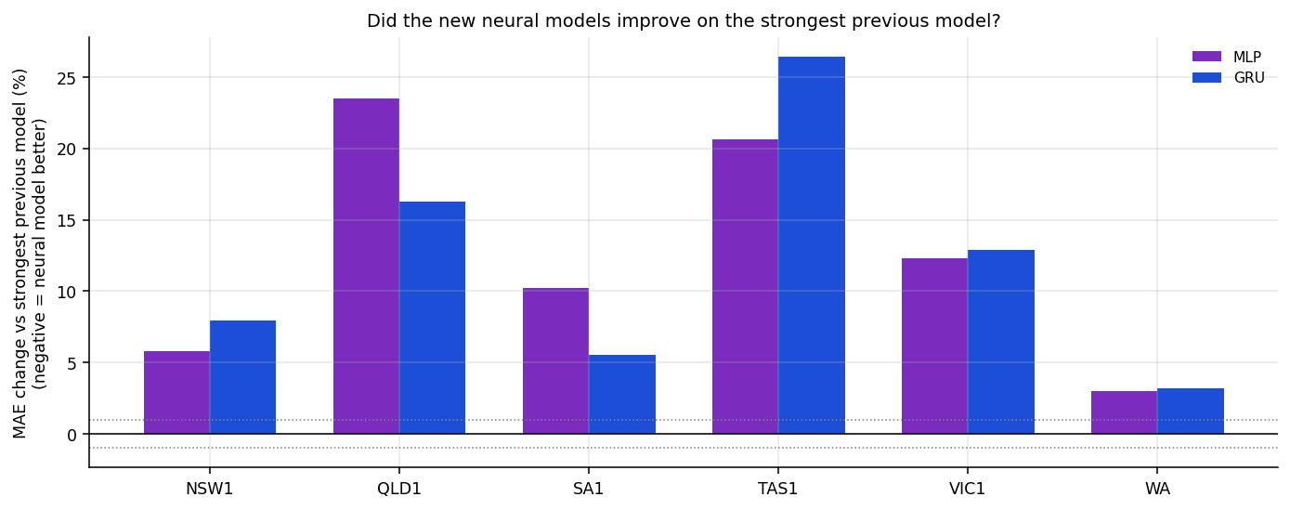
Figure 1. MAE change of MLP and GRU versus the strongest previous model by region (positive = worse).

4. Model-selection integration
The selection rule written before the run chooses, among fully ready models on the three full-history origins, the lowest mean four-month MAE, with a 1% practical-tie band and a declared tie-break chain. Ashish integrated the ten-model evidence into the final decision table. In every region the leader was outside the 1% band, so no tie-break was needed.
Table 4. Final regional decision (regional_model_winners.csv)
Region | Selected model | MAE (MW) | nMAE % | Runner-up | Margin
NSW1 | RandomForest_A | 604.8 | 8.81 | RandomForest_B | +2.1%
QLD1 | RandomForest_A | 438.2 | 7.28 | RandomForest_B | +5.1%
VIC1 | RandomForest_A | 457.1 | 10.62 | RandomForest_B | +2.6%
SA1 | RandomForest_B | 186.4 | 16.77 | RandomForest_A | +1.6%
TAS1 | RandomForest_A | 70.9 | 6.87 | RandomForest_B | +1.0%
WA | RandomForest_B | 204.5 | 10.90 | MLP | +3.0%

The common-model analysis showed that RandomForest_B everywhere would cost QLD1 5.1% accuracy (above the 3% materiality threshold), so the recommended deployment is a hybrid: one Random Forest code path with Feature Set A or B chosen per region. The regional selections are identical to WP3, with MAE changes of at most 1.8% after the WP4 leakage correction — evidence that the WP3 decision was robust.

5. WP4 module delivered
Table 5. Module summary
Item | Detail
File | Individual_Code/WP4_Ashish_MLP_Model_Integration.py (with shared wp4_contracts.py)
Main functions | mlp_parameters(), mlp_input_contract(), build_mlp_network(), chronological_validation_mask(), fit_scalers(), WP4MLPForecaster.fit/predict/architecture, run_mlp_backtest(), registry_entry()
Contract objects | ModelInputContract, NeuralScalerBundle (records fitted_until, asserts it precedes the origin), ForecastResult
Integration target | Pipeline Section P (scalers, callbacks), Section Q (MLPLearner), MLP branch of run_model() in Section T
Equivalence result | 11/11 checks pass: parameters, feature order, trend exclusion, registry entry, 56-day validation block, training-only scaler, full and quick parameter counts, and identical predictions from an identical seed

6. Collaboration, review and next steps
Table 6. Issues from GitHub_Issues/ (package numbers; GitHub will assign its own numbers)
Package issue | Title | Ashish's role | Branch
01 | MLP model architecture and integration | Owner | wp4/ashish-mlp-integration
03 | MLP pair integration review | Co-owner with Bishal | review only
09 | Four-module integration into final pipeline | Integration lead | wp4/neural-model-integration
11 | Final report-result evidence update | Primary (Bishal reviews) | wp4/report-evidence
02 | MLP validation and evidence framework | Reviewer of Bishal's PR | —

- Run create_wp4_github_issues.sh, open the branch and push the module with its equivalence output attached.
- Review Bishal's validation PR by running it locally before approving.
- Merge the four modules in the order in WP4_INTEGRATION_CONTRACT.md, re-running run_wp4_equivalence_tests.py after each merge; label any behaviour change rerun-required.
- Confirm every number in the final report against the evidence register (Issue 11).

7. Code and evidence artefacts
Table 7. Evidence used in this report
Artefact | Purpose
metrics/neural_vs_previous_comparison.csv | MLP versus previous champion, by horizon and origin
metrics/regional_model_winners.csv; summary/selection_trace.txt | Final selection and trace
metrics/common_model_summary.csv | Common vs hybrid strategy
metrics/computational_cost.csv | MLP runtime (mean 12.7 s per run)
Report Sections 9, 14, 25–27 | Where the MLP and selection evidence is presented

8. Professional reflection
The most useful outcome of Ashish's WP4 work is a negative result that can be defended. It would have been easy to present a new neural model as progress; the evidence shows it did not improve the forecast, and the selection rule — fixed before the results — made that conclusion unavoidable. Designing the MLP so that it had exactly the same information as Random Forest (including the refit on the final eight weeks) was the part that required most care, because any shortcut would have biased the comparison in one direction or the other. The main lesson carried forward is that model-selection credibility comes from the rule and the evidence trail, not from the complexity of the candidate. (Reflection to be confirmed and personalised by the student before submission.)

